EXPERIMENT-5

AIM: To create a HTML form.

The HTML <form> element defines a form that is used to collect user input.
HTML Forms are required, when you want to collect some data from the site visitor. For example,
during user registration you would like to collect information such as name, email address, credit
card, etc.
A form will take input from the site visitor and then will post it to a back-end application such as
CGI, ASP Script or PHP script etc. The back-end application will perform required processing on
the passed data based on defined business logic inside the application.
There are various form elements available like text fields, textarea fields, drop-down menus, radio
buttons, checkboxes, etc.
The HTML <form> tag is used to create an HTML form and it has following syntax −
The <form> element can contain one or more of the following form elements:
- <input>
- <textarea>
- <button>
- <select>
- <option>
- <optgroup>
- <fieldset>
- <label>

Code:

HTML

SignUp.html

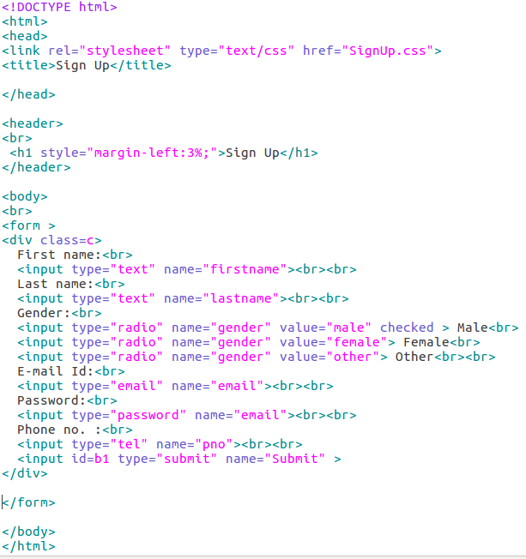

CSS
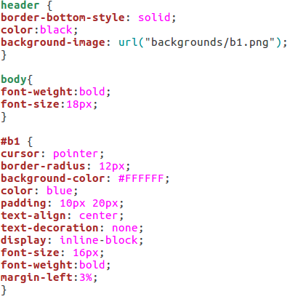

Output

